Adam Gincel

BT321

Homework 2

1)

a) 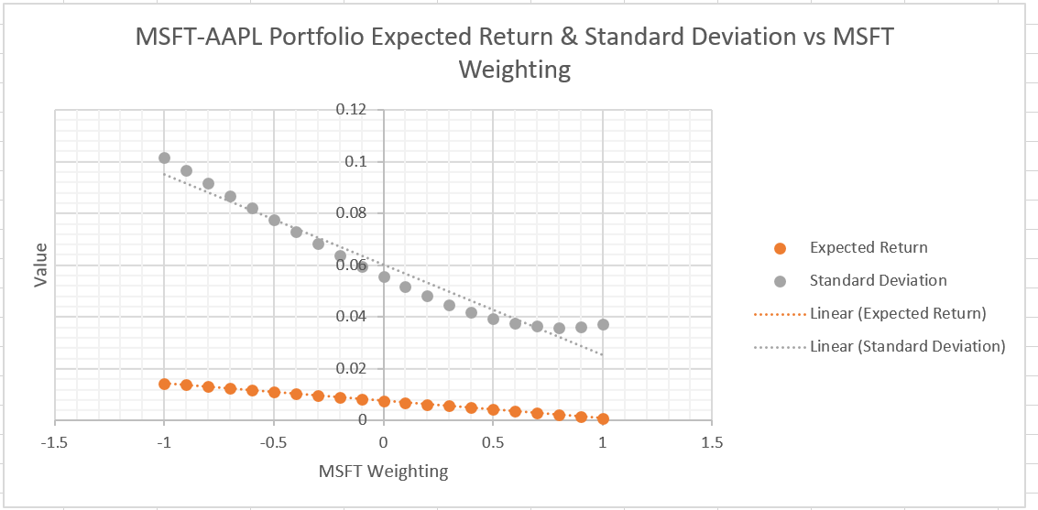

b) 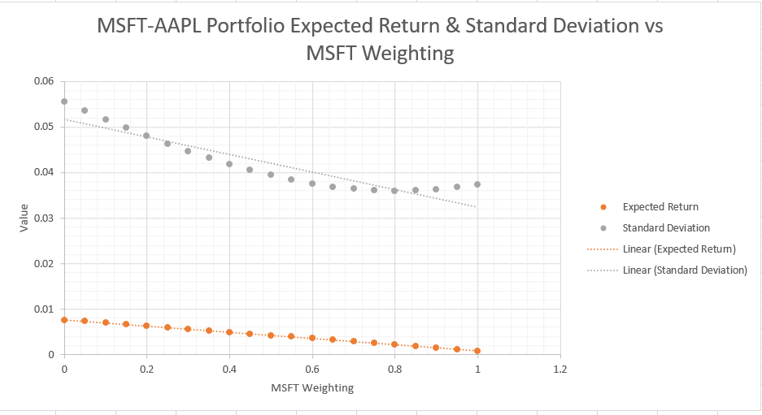

c) Imposing short-sales constraints on a market appears to reduce both overall average expected return, while also reducing standard deviation on the return of the portfolio. It seems to allow for lower risk, lower return portfolios.

d)